Learning project week – At the seaside Week 9
The Night Pirates – Peter Harris and Deborah Allwright

Reading Challenge 2020 – The Library reading challenge has begun! It is all online and easy to sign up just click on this link https://summerreadingchallenge.org.uk/
For more information the letter is on the bottom of this pack!

Would you like a merit award? Your teachers are going to pick a child working from home and a child in school to have a merit each week. It could be you! Make sure you are emailing in pictures of your work. Good luck
For more information see letter on the bottom of this pack!
Age range EYFS/ Reception
Dear Reception,
Please find this week’s learning. Our new topic is ‘At the seaside’. Our key book is ‘The night Pirates’. You will find a link to the story below.

Please aim to try and complete 1 maths, reading, phonics and writing activity a day.
If possible, please take part in the Ruth Miskin daily phonics lesson will be a great way of your child learning their phonics.
We have added printable sheets at the bottom of this for those people who wish to use them. There are 100s of free printable activities related to the seaside on Twinkl.
If you haven’t got access to a printer and would like resources to be printed, please contact your teacher and we can arrange for packs to be made.
Thank you so much to everyone who took the time to email your teacher. We loved seeing all your learning. We’d also love to hear from you any tips on useful websites or learning you have used that other parents would find useful.
Thank you for all your support. We really appreciate all you are doing.
Take care and best wishes from the Reception Team
sa.magill@violetway.org
b.price@violeyway.org
d.collins@violetway.org

Maths  (Aim to do 1 per day) | Reading  (Aim to do 1 per day)
Follow the activities on: White Rose maths - https://whiterosemaths.com/homelearning/early-years/ week 9 – beginning ^{22nd} June  This week’s theme is – Taking away and counting backwards  Key vocabulary: take away, subtract, less, smaller, first, then, now  Monday – Can you count backwards? – You can use a number line or your finger. (sheet below)  First there were 10 children on the bus and then 2 got off. How many are on the bus now?  Can we write the number sentence?  How many are on the bus at the start?  How many MORE get on the bus?  Is it add or take away?  Can you write the number sentence?  10 – 2 =  Use a number line or fingers to solve the problem.  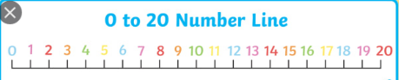  Tuesday – Can you take away by crossing out?  A Pirate had 8 coins the captain hook took away 4. How many has he got now?  How many coins does your pirate have first?  How many more coins got taken? – cross out that amount of coins  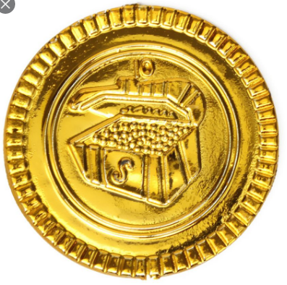  =  (Sheet below to complete)  Wednesday – Practical lesson – Can you take away by counting backwards?  You will need 10 coins.  Adult says I have _____ coins in my pot now.  The adult then takes some away.  How many are in my pot now? –  Can the children work it out – Use fingers – We started with 9 coins and I took 5 away. 5 fingers down – How many are left? Check in the pit to see if they are correct.  Let the child to start with coin and take some away for the adult. Child to check the adults working out.  Thursday – Can you understand and create word problems.  First there were 6 ships and then he lost 3. Now he has ____  ____ + _____ = ________  Talk about how we use the word problem to write the number sentence – Count backwards to find the answer – You can draw and cross out coins or use real coins if it helps  (Sheet below – Create your own word problem)  Friday – Can you take away by counting backwards on your fingers?  7 - 3 =  Put 7 fingers up – fold 3 fingers down. How many have you got left?  Practice these songs everyday before maths  Count forwards to 20 song https://www.youtube.com/watch?v=7D4K9oi7oBMC  Count backwards to 20 song https://www.youtube.com/watch?v=ShqXL-zfLxY | The Night Pirates - The night pirates - https://www.youtube.com/watch?v=KnVP6iBAvHg  Pirates Stories – https://central.espresso.co.uk/espresso/primary_uk/subject/module/frontscreen/item1111868/grade1/index.html  Username-student27647  Password-violet  Lighthouse keepers lunch -  https://www.youtube.com/watch?v=46wCRq50Wwg  Oxford owl book  You will need to log into oxford owl before you can access the book. It is free.  https://www.oxfordowl.co.uk/api/interactives/29256.html  Nip and chip  - Page 6 – What are the monkeys names?  - Page 8 – What kind of log did they hit?  - Page 9 – Was it a log? What was it?  - Page 10 – What did the jump on to?  - Page 11 – Why did they want to jump of quick, quick, quick?  Poems and nursery rhymes - Go to BBC schools radio Nursery Rhymes  https://www.bbc.co.uk/teach/school-radio/nursery-rhymes-a-to-h-index/z4ddgwx  Find a rhyme/song you can learn and enjoy by heart  Ongoing reading activities  - Read a variety of books at home. Favourites can be repeated. Hearing the patterns of language in a story will support your child’s language development.  - Children to read to parents daily.  - https://www.oxfordowl.co.uk/for-home/find-a-book/library-page/ Oxford Owl has free eBooks to read.  - With your child, look in magazines, newspapers and books for the tricky words they are currently learning. They could use a highlighter to highlight in magazines and newspapers.
Writing  (Aim to do 1 per day)  Please remember that in reception children are at very different levels of writing ability. Some will confidently be able to write sentences whilst others will just attempt to write words to go with pictures. | Phonics  (Aim to do 1 per day)
The night pirates - https://www.youtube.com/watch?v=KnVP6iBAvHg  - Monday – Phonics focus - See phonics section – Focus on sounds air, ir, ou, oy  - Tuesday – Topic words – Can you practice spelling these topic words?  ring beard hat hook map gold silver  Can you write a sentence using one or two of these words?  - Wednesday – Can you write about what is in the treasure chest? (Sheet below)  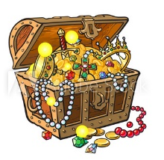  - Thursday – Can you plan your own pirate story?  Sheet below – There are three pages – Page 1 is for the beginning, page 2 is for the middle and page 3 is for the end.  Draw a picture on each page  Page 1 – Your Pirate  Page 2 – What does he find on his journey?  Page 3 – What does he do with it?  - Friday – Can you write your own pirate story?  Write 1 or 2 sentences under each picture you drew yesterday.  Remember  Think it, Say it, write it, check it  Extra Writing ideas  - Can you draw a picture of a treasure chest and write a few sentences about what you have put in it. | Take part in daily phonics lesson:  www.ruthmiskin.com/en  Ruth Misken You Tube – Watch daily phonics lesson 9.30 Set 1 sounds 10.00 set 2 speed sounds. (Children in Miss Gower’s, (initial sounds) Mrs Taylor’s (green words) and Mrs Collins’s (ditty books) phonics group can focus on watching set 1 sounds. Children in Mrs Magill’s (green books) and Miss Price’s (pink books) phonics can watch set 2 sounds video.  The sound the weeks are  air, ir, ou, oy  Can you write these words on some flash cards to practice every day,  air, fair, twirl, girl, shout, found, boy, toy  Can you read this sentence containing this weeks sounds? Can you circle the special friends?  The girl went to a fair and found a toy.  The boy did a twirl.  Printable activities  - Practicing our sounds for the week. There is a sheet for each sound.  - Read and match sheet  Espresso phonics - FS – Literacy – Phonics - You can take part in a range of games and watch videos in phase 1 and 2.  https://central.espresso.co.uk/espresso/primary_uk/subject/module/sub_modules_index/item72024/gradef/index.html?source=subject-Literacy-F-Literacy-Resource%20types  username-student27647  Password-violet  Phonics play games- username: march20 password: home  https://www.phonicsplay.co.uk/  - Espress – foundation – phonics – activities – for a range of games
Other
Pirate boats
Look at a pirate ship – Can you name the parts of the ship?
Look at the PowerPoint saved on the home learning page
Can you colour in a ship and label it with different parts

Music
Charanga – You can find your username and password in your red book.
https://www.entrustinteractivemusic.co.uk/yumu

Creative – Can you make your own treasure chest?
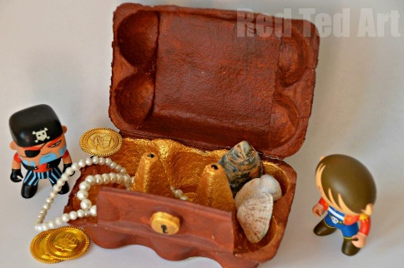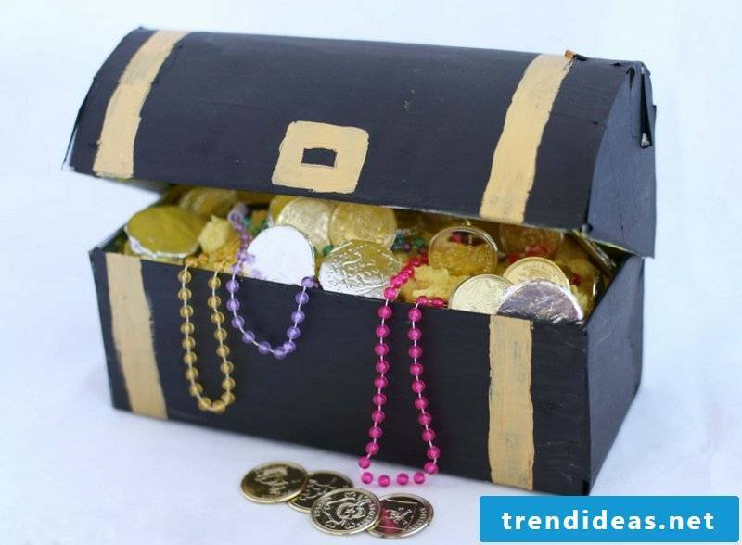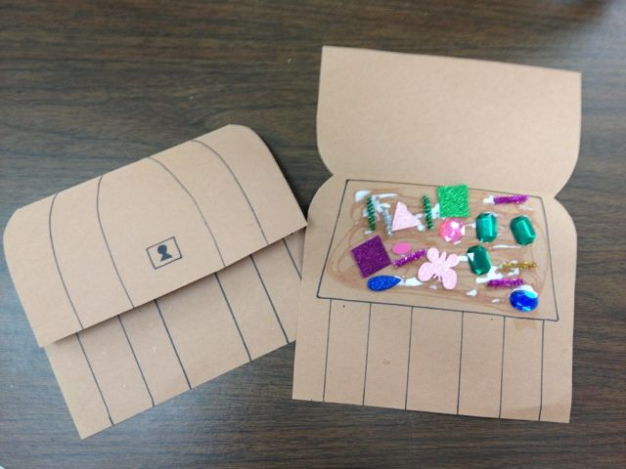
Write a few sentences about what you have put in your treasure chest.

Investigate – Can it float?
https://www.youtube.com/watch?v=eQuW8G2QV_Q
Experiment
Find some objects around your house
Before you put them in the water predict what you think it will do
Why do you think each object sinks or floats?
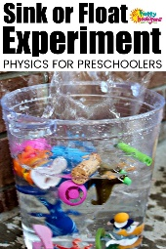

Can you make your own pirate ship?
Can you make your own pirate ship out of junk modelling? Does it float? What kind of material do you think you will need to make it out of so it floats?
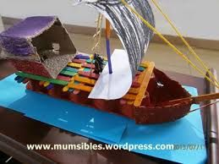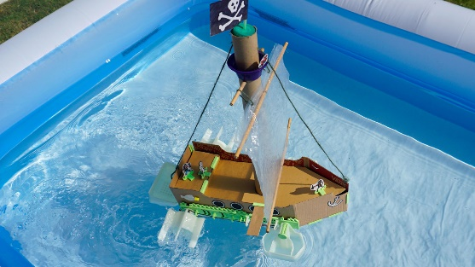

PHSE
Join the National Assembly on Thursday at 11am or any time after on https://www.thenational.academy/assembly

Technology
Can you use this simple computer program? Have a look round.
What videos/games can you find?
Espresso – Foundation - Pirates
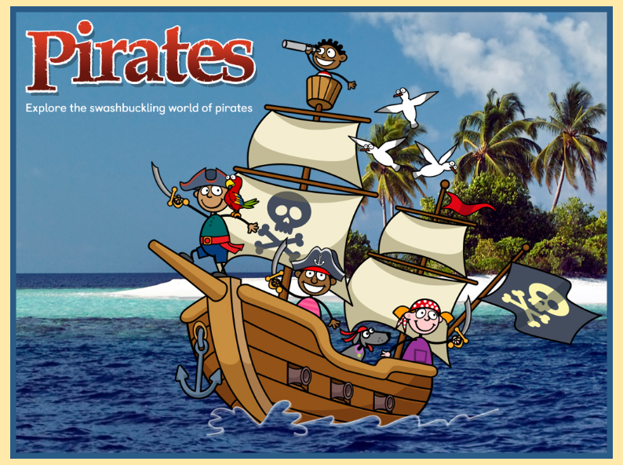
https://central.espresso.co.uk/espresso/primary_uk/subject/module/frontscreen/item1111868/grade1/index.html
Username-student27647
Password-violet
Can you design your own pirate?
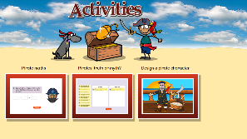
Purple mash
Purple Mash –Role play – add your photo to the pirate and create your own
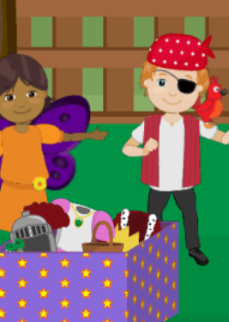
OR
Or make up own story on purple mash – draw pirate ship and setting for your story
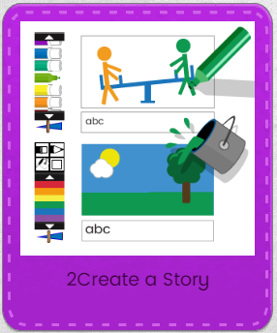

PE and physical development
- Remember your daily workout! Check out the exercises from Joe Wicks 😊 https://www.youtube.com/watch?v=d3LPrhI0v-w
- Espresso – Foundation – Expressive arts – Sing and pretend – Join in our favourite class dances
- Cosmic yoga is also good exercise. Please follow the link https://www.youtube.com/user/CosmicKidsYoga.
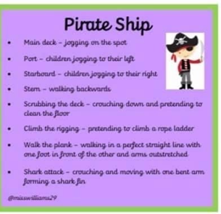

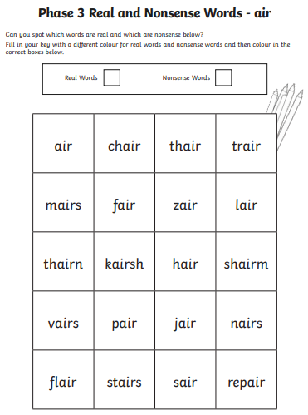

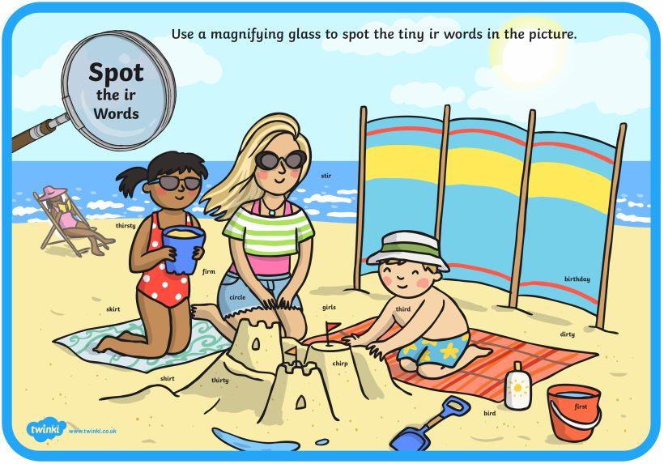
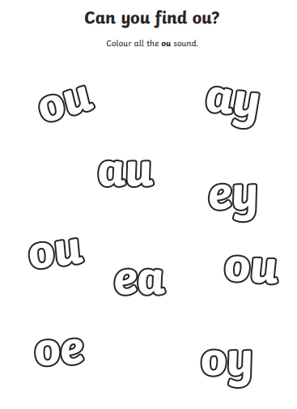

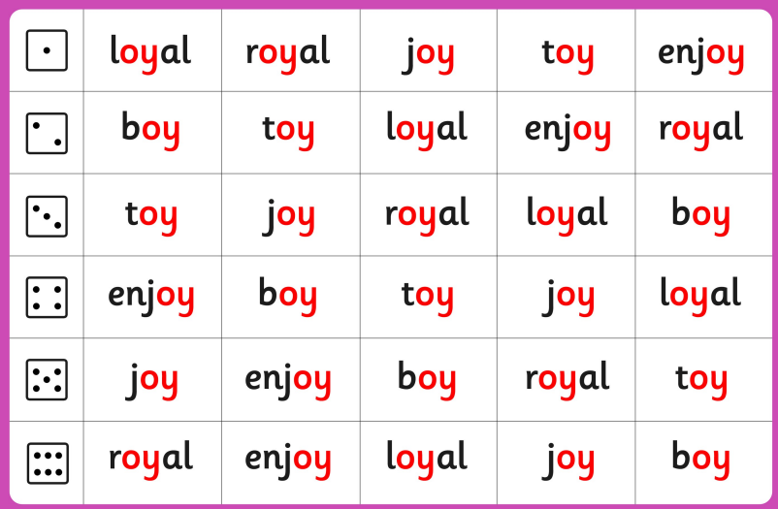
Tuesday – Writing –
Practice spelling these topic words
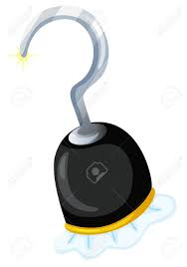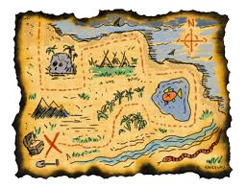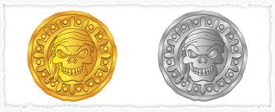
Ring beard hat hook map gold silver

Can you write a sentence using at least one of these words?
Remember – Think it – Say it – Write it – check it
______________________________________________________________________________________________________________________________________________________________________________________________________________________

Writing – Wednesday – Can you write about what’s in the treasure chest?
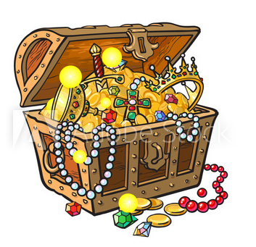
Remember – Think it – Say it – Write it – check it
______________________________________________________________________________________________________________________________________________________________________________________________________________________

Thursday and Friday Writing
Thursday – Draw your pictures. Friday – Write your story
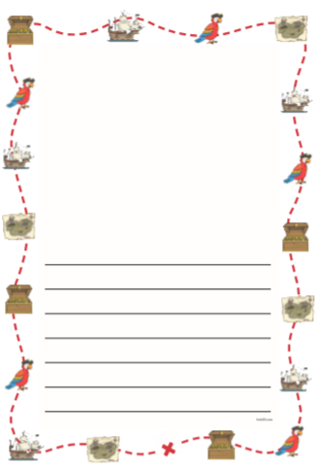
Beginning
middle
end

Monday – Math – Counting backwards – Bus Game
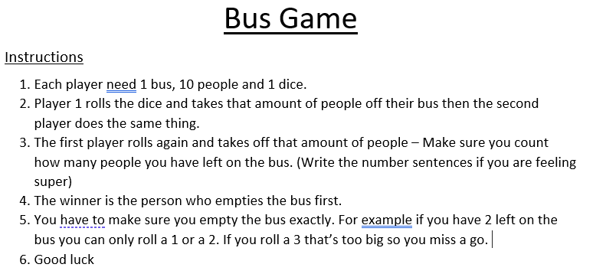
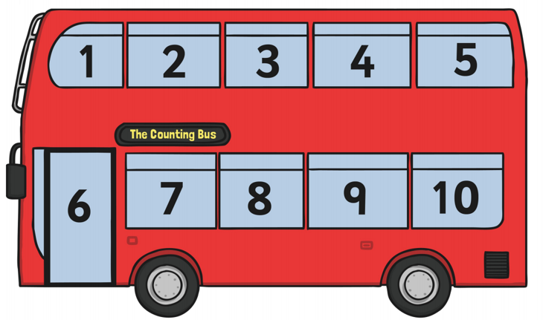
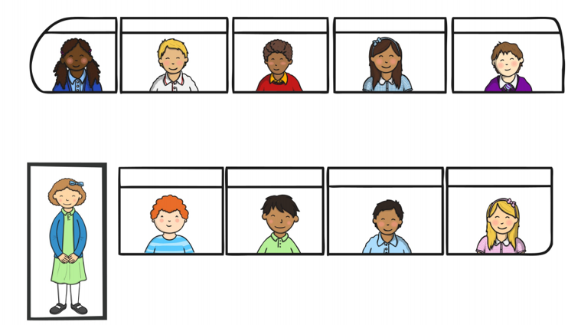

Tuesday – Maths – Taking away by crossing out
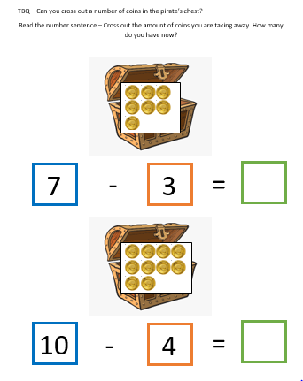

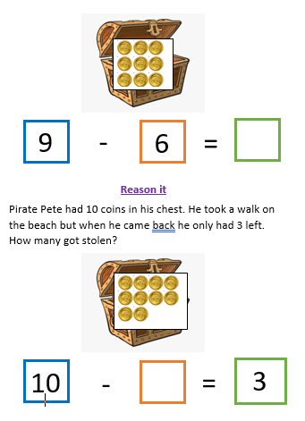
Thursday – Maths – Create your own word problem
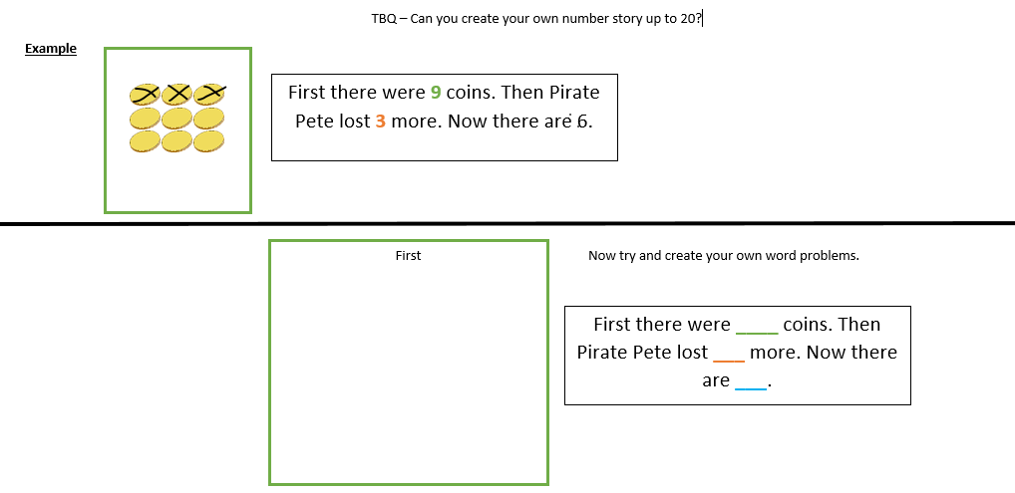
Friday – Maths
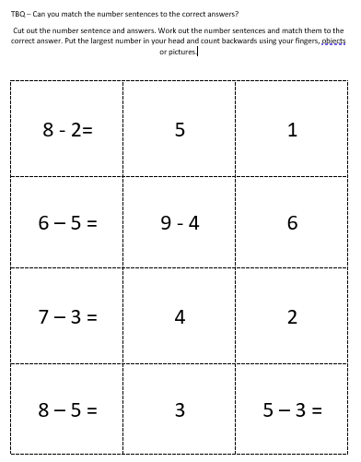

Colour and label a pirate ship
Cut and stick the labels
flag | port hole | sail | mast | stern | bow

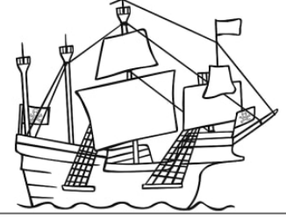

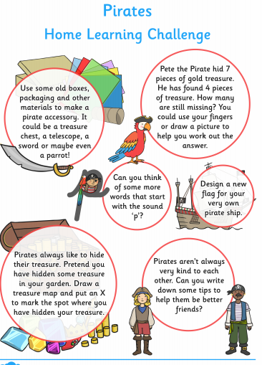

VIOLET WAY MERITS ARE BACK!

At Violet Way we are enjoying having some of our children back in school and they are working so hard. Class teachers also know that children at home are working really hard with their home learning from all of the email updates we have been getting.
We would like to celebrate all of the hard work children have been doing both in school and at home by giving out weekly merits. Although we can’t celebrate them altogether in our merit assembly we can share our merits on the school website and email merit certificates to the children so they have one to keep.

Each Reception and Year 1 teacher will choose a merit for someone who has been working hard in school in their bubble and a merit for someone for someone who has been doing some brilliant home learning. Year 2 teachers will choose a merit for home learning and for a child from the Year 2 Key Worker bubble.

Please make sure you keep emailing home learning to class teachers so they can see what you have been up to.

We look forward to giving out some merit certificates very soon!



