Learning project week – Minibeasts Week 3
The Hungry Caterpillar
Age range EYFS/ Reception

Dear Reception,
Please find this week’s learning which continues on the theme of minibeasts. Our book this week is, “Aghhhhhh Spider!” and you can watch Mrs Magill read this on the website. You will also find photographs and videos from Reception Staff linked to this week's topic.

Please aim to try and complete 1 maths, reading, phonics and writing activity a day.
If possible, please take part in the Ruth Miskin daily phonics lesson will be a great way of your child learning their phonics.

We have then given a range of other learning linked to minibeasts, Ramadan and VE day which you can choose from.
We will be adding videos and pictures throughout the week on twitter linked with the topic so if possible, please go and have a look.

We have added printable sheets at the bottom of this for those people who wish to use them. There are 100s of free printable activities related to minibeasts on Twinkl.
If you haven’t got access to a printer and would like resources to be printed, please contact your teacher and we can arrange for packs to be made.

Thank you so much to everyone who took the time to email your teacher. It was fantastic to see your wonderful learning and hear from you. Please keep in touch and we welcome any feedack, questions or comments.

Thank you for all your support. We really appreciate all you are doing.
Take care and best wishes from the Reception Team
sa.magill@violetway.org
b.price@violeyway.org
d.collins@violetway.org

Maths  (Aim to do 1 per day) | Reading  (Aim to do 1 per day)
Follow the activities on: White Rose maths - https://whiterosemaths.com/homelearning/ Great ideas of maths activities and a video to watch to explain learning. Just go to the Early Years section and follow the activities.  Or Other Follow:  This week’s theme is “Odds and Evens”.  Children will learn that quantities that can be shared into two equal groups with none left over are even. Or if put into groups of twos have none left over.  Objects which when shared into two equal groups and have one left over are odd. Or if put into groups of two has one left over.  1) Watch BBC Numberblocks Odds and Evens episode:  https://www.youtube.com/watch?v=KEw2E1gG8Ak  Join in and sing along to this odd and even song – Jack Hartman Odds and Evens  https://www.youtube.com/watch?v=x1EGRUXmNdY  2)Sorting in pairs Give children a selection of objects (e.g. socks, pens, small figures) Can they put the objects into pairs without any being left over? Draw a picture to show their number. Which numbers are odd? Which are even?  3) Cut and sort the numicon shape pieces below and sort in your books under the headings “Odd and even”. Write the numbers next to them.  4) House numbers Go out for your daily walk if possible and look at the house numbers. Can you spot odd and even numbers. Make your own model houses and label the odd and even sides of the road.  5) Sorting objects into two groups Set up a teddy bear picnic with two teddies and two plates. Give different quantities of play food or objects (e.g. 5 sweets, 3 carrots, 10 grapes) and ask children to share between the two teddies. Which numbers are equal and which are odd? Draw a picture of some of the objects to show your findings.  6) Using building bricks build towers using odd and even numbers.  Problem Solving  What happens if you have an odd number of bricks and add 1 more? What happens if you have an even number and add one more?  Worksheets  There are a number of odd and even worksheets below that your child may wish to complete. | - Key books: Read or watch the book ‘Aghhhh a spider’  https://www.youtube.com/watch?v=5df388jmToo  - Draw a story map to help retell the story.  - Retell the story to a toy.  - Learn and recite “Incy Wincy Spider” - try making up your own version.  - Read non-fiction minibeast facts on children's websites.  Ongoing reading activities  - Read a variety of books at home. Favourites can be repeated. Hearing the patterns of language in a story will support your child’s language development.  - Children to read to parents daily.  - https://www.oxfordowl.co.uk/for-home/find-a-book/library-page/ Oxford Owl has free eBooks to read.  - With your child, look in magazines, newspapers and books for the tricky words they are currently learning. They could use a highlighter to highlight in magazines and newspapers.  Printable activities below  Read the captions/ sentences and draw the picture.  Read the sentences and match them to the correct picture.
Writing  (Aim to do 1 per day)  Please remember that in reception children are at very different levels of writing ability. Some will confidently be able to write sentences whilst others will just attempt to write words to go with pictures. | Phonics  (Aim to do 1 per day)
- Fact file - With your adult read the facts about the spiders on this PowerPoint. Then Make your own fact books about spiders. (Miss Price will put a video on Twitter showing you hers)  - Description - Make your own spider out of junk modeling (see ‘other’ below for photos) and then write description about it. (Write your description in your red book)  - Instructions - Write some instruction about how to look after your spider. (Write these in your red book_  - Letter writing - Write a letter to you teacher – tell her everything you have been up to – Get your adult to take a picture of it and send it to our email addresses above. (You never know we might even write back)  - List - Write a list of words containing oo (poo) and oo (book) | Take part in daily phonics lesson:  www.ruthmiskin.com/en  Ruth Misken You Tube – Watch daily phonics lesson 9.30 Set 1 sounds 10.00 set 2 speed sounds.  (Children in Miss Gower’s, (initial sounds) Mrs Taylor’s (green words) and Mrs Collins’s (ditty books) phonics group can focus on watching set 1 sounds. Children in Mrs Magill’s (green books) and Miss Price’s (pink books) phonics can watch set 2 sounds video.  The sound the week is the long oo and the short oo: https://www.youtube.com/watch?v=UfMKV_9agiY  https://www.youtube.com/watch?v=vR47jG-imRo  Find words containing these sounds in books and around your home.  - Please can you write these words on cards and practise sounding them out with your children. They will need to sound out using the short and long oo sound and decide which one sounds right (book, poo, swoop, broom, took, look, book, zoo, zoom, foot)  Espresso phonics - FS – Literacy – Phonics - Phase 2 – oo videos and activities  Phonics play games- username: march20 password: home  https://www.phonicsplay.co.uk/  - Espress – foundation – phonics – activities – for a range of games  Printable activities  - Can you read these simple sentences containing the oo and oo sounds.
Other
Art and design
- Make your own spider out of junk modelling – You spider must have 8 legs but other than that let your creativity run wild.
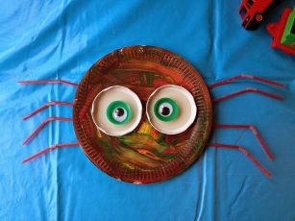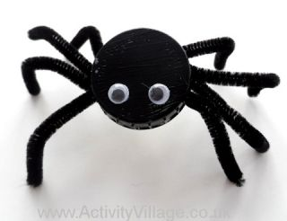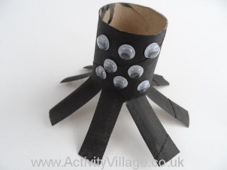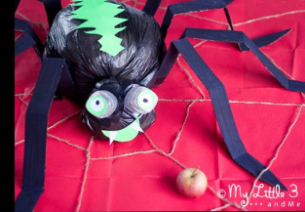
- Use string to make your own art – Watch you tube link. https://www.youtube.com/watch?v=ed9edPmPKjU
- Make your own spiders web.
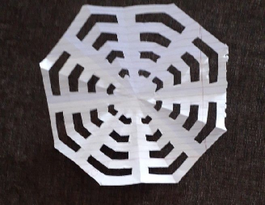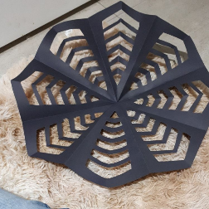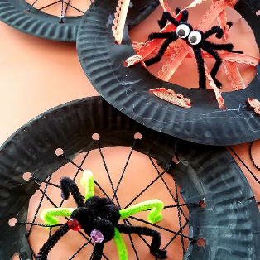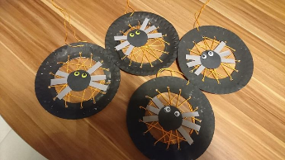
- Make your own playdough minibeasts.
Understanding the World - Minibeasts
- Watch https://www.youtube.com/watch?v=WUx2qqPUyOI - about spiders
- Play the minibeast game on BBC website: https://www.bbc.co.uk/games/embed/gvy6rtlqjw?exitGameUrl=https%3A%2F%2Fwww.bbc.co.uk%2Fcbeebies%2Fgames%2Fmini-beast-adventure-with-jess-minibeast-spotter (when on your hunt use this game on a tablet or phone – once you find a minibeast you can tick it off and find out facts about it.)
- Make your own minibeast home.
- Draw and match habitats to what minibeasts live there or complete attached sheet (see below for sheet)
- GO TO ESPRESSO – KS1 – Science – Minibeasts and watch and play the activities www.discoveryeducation.co.uk student27647 password violet

Ramadan
- Go to Espresso – Foundation – Understanding the World – Ramadan – Watch video and carry out snap game and
- There is a mindfulness colouring sheet and a word search for Ramadan attached.

VE Day 8th May
- Why not make some bunting to decorate your home for VE Day?
- Find out about VE day by searching VE day in the Espresso search
- Join in the school VE day challenge (see below). Colour in your flag and send in a picture of you with it.

PE and physical development
- Remember your daily workout! Check out the exercises from Joe Wicks 😊 https://www.youtube.com/watch?v=d3LPrhI0v-w
- Espresso – Foundation – Expressive arts – Sing and pretend – Join in our favourite class dances
- Cosmic yoga is also good exercise. Please follow the link https://www.youtube.com/user/CosmicKidsYoga.

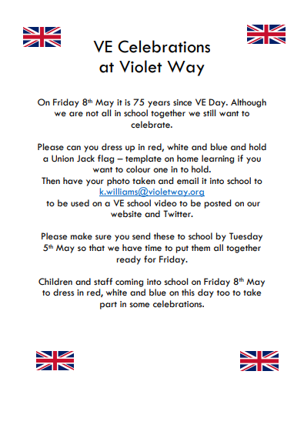

Cut out and sort these numicon pieces into odd and even numbers. Write the numbers next to each piece.
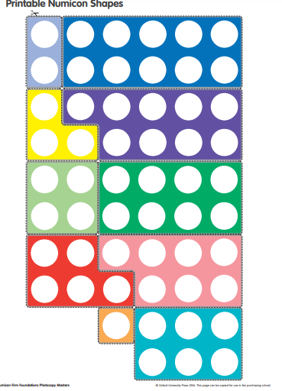

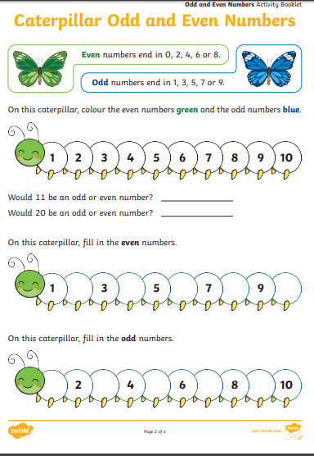

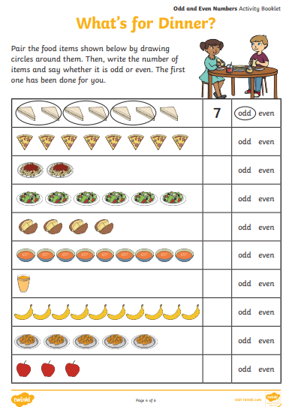

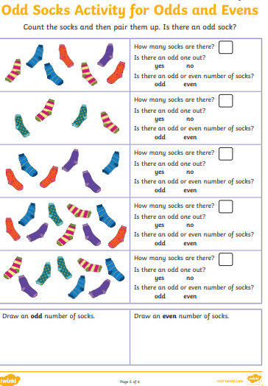

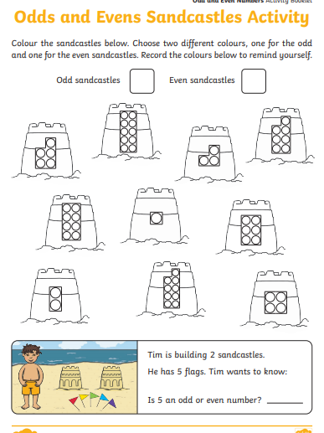
Read and draw these simple captions containing diagraphs
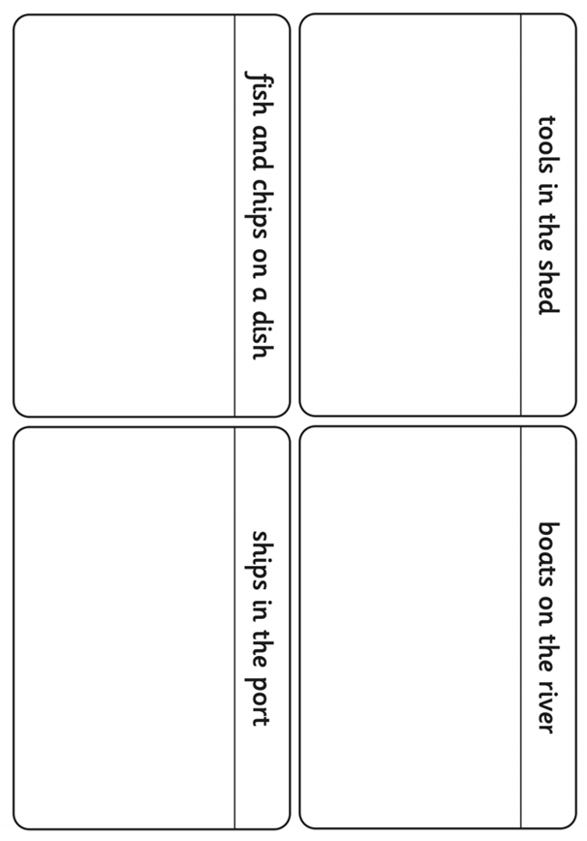

Read and draw these CVCC words

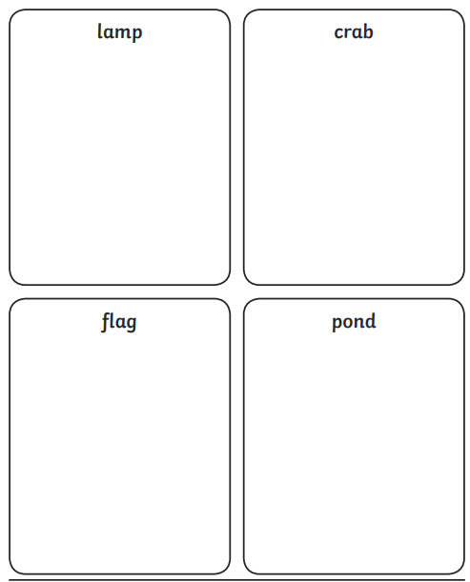

CVC words

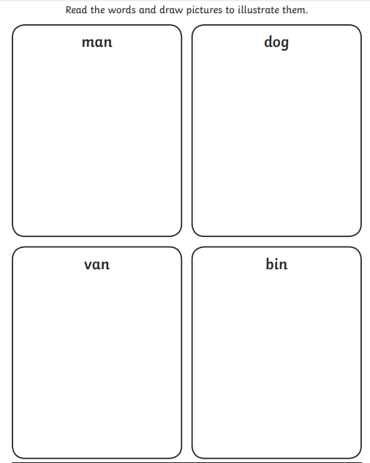

Match the captions to the correct pictures
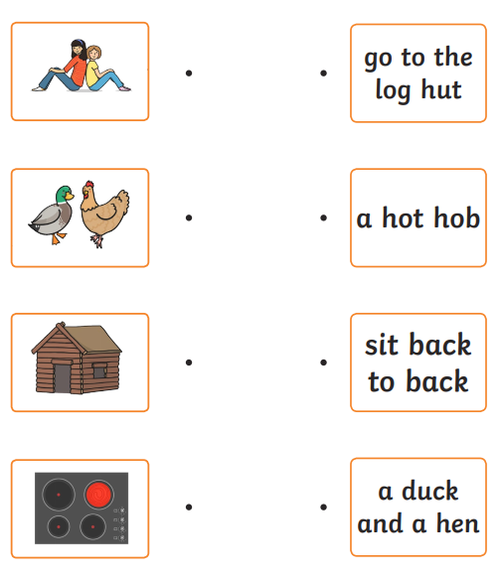

Match the captions to the pictures. (These have some tricky diagraphs in)
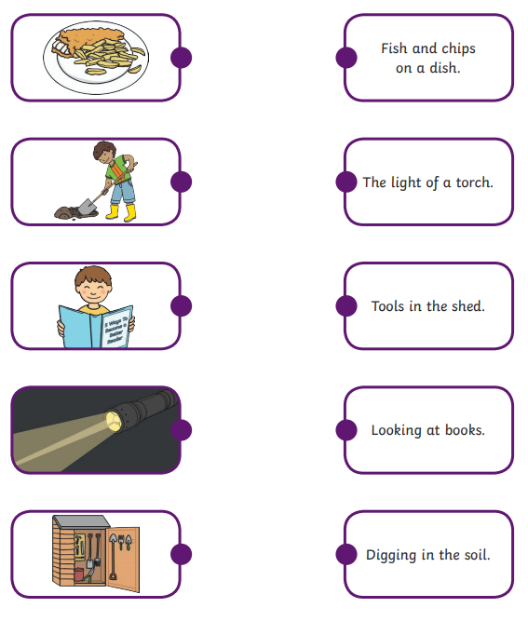

Please read the ‘oo’ and ‘oo’ sentences

I can see a book.
The book is at a zoo.
I just put my foot in poo!
I took my broom and swept the poo. It was yucky!

Miss Fairbrother has made a Spiders word search for you!




