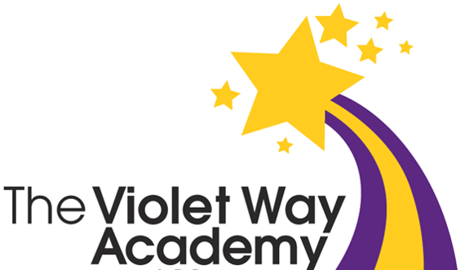

Inspiring all to excellence
· respect · integrity · humility · equality · care towards all

Violet Way Academy

Remote Learning Plan

Rationale
Our priority is to deliver face-to-face, high-quality education to all pupils. The evidence is clear that being out of education causes significant harm to educational attainment, life chances, mental and physical health.
In the event of school closure, Violet Way Academy is committed to providing a continuity of education to its learners. This will be provided through remote (online) learning. Extensive remote learning would apply particularly in a situation in which VWA is closed for an extended period of time, but a high proportion of pupils and teachers are healthy, and able to work as normal from home.
Remote learning may also be appropriate in situations when pupils, in agreement with the school, have a period of absence but are able to work at home, at least to some extent. This may apply in cases such as exclusion from school, or longer-term illness, assuming pupils are able to complete school work at home.
Flexibility of Learning
We realise that the circumstances that cause our school to close or of a child being unable to attend school, for long-term medical reasons for example, will affect families in a number of ways. In our planning and expectations, we are aware of the need for flexibility from all sides: -
- technology as a family may be limited
- systems may not always function as they should

An understanding of, and willingness to adapt to, these difficulties on all sides is essential for
success. Paper copies of learning can be provided where necessary in some situation.

Expectations for families
We believe that it is in the best interests of our children that we continue to provide structured support to the best of our ability. It must be noted that the work children engage in during a period of closure will be part of our current planning and so should not be considered as optional. Children and parents should consider the arrangements as set out in this document as highly recommended. Where families have made school aware, they have no devices for online learning, alternative arrangements will be made (Appendix 4).
Delivering Remote Education Safely
Keeping children safe online is essential. At Violet Way we follow the statutory guidance Keeping Children Safe in Education which underpins how we protect children online. Please see our Child Protection and Safeguarding Policy for more information. Teachers will refer to the guidance in Appendix 2, which must be followed to safeguard yourself and the learners.

Parents can make references to the posters in Appendix 5 and/or visit Think You Know (Online Safety) https://www.thinkuknow.co.uk/ for tips and advice.

For individual children unable to attend school for extended periods due to a medical condition or need:
Parents will: -
- Support their child’s learning to the best of their ability.
- Contact the school through Arbor/ Teams/ Tapestry if there are any concerns or support is needed.
- Ensure that children have access to the learning provided by the school.
- Contact the school through Arbor or the school office if there are any concerns or support is needed.

Teaching Staff will: -
- Ensure that children have access to home learning that reflects missed learning in school.
- Ensure pupils have online access to the reading scheme and are directed to books that match their reading ability.
- Ensure pupils can access resources to support phonic skills in line with their reading ability.
- Provide verbal or written feedback through Teams or Tapestry.
- Report any concerns to SLT.
- Respond to queries as soon as possible when they are not in class.

Children will:
- Follow the timetable or work instructions provided with support from an adult.
- Ensure that learning they are completing is to the best of their ability.
- Only access materials that have been shared by teaching staff or by parental permission.

For Partial or Full School Closures
Parents will: -
- Will follow the timetable (see Appendix 1 for examples) and instructions given by the school and ensure they do not send their child/children into a school setting during the closure unless contacted individually.
- Support their child’s remote learning to the best of their ability.
- If your child is unable to complete work remotely from home due to feeling unwell you must contact class teachers to let them know via Teams / Tapestry /Arbor or email.
- Ensure work is submitted daily to class teachers via Teams / Tapestry. If no work has been submitted for two days, then the school will be in contact with you.
- Contact the school if there are any concerns or support is needed via Teams / Tapestry / Arbor or the school office.

Teaching Staff will:
- Provide learning closely linked to the school’s medium-term plans and integrated into the school’s curriculum planning to ensure no lost learning.
- Provide pre-recorded video lessons and / or Oak Academy video lessons for English, Maths and Foundation lessons.
- Provide feedback for learning through Teams / Tapestry.
- Keep a log of completed remote learning to ensure it is being accessed daily and to feed back to a member of SLT if a child does not complete any learning for two days and parents have not been in touch to give a reason for this.
- Will give out Arbor Thumbs Up points for each completed home learning task.
N.B The staff member providing the learning and giving the feedback may not always be the class teacher.

Children will: -
- Follow the class timetable for their learning at home.
- Ensure that learning they are completing is to the best of their ability.
- Only access materials that have been shared by teaching staff or by parental permission.

Approaches to teaching pupils remotely may include:
- Recorded teaching e.g., video/audio recordings made by teachers.
- DfE recommended lessons i.e. Oak Academy
- Printed paper packs produced by teaching staff.
- Textbooks and reading books pupils have at home.
- Commercially available websites supporting the teaching of specific subjects or areas, including video sequences or clips.
- Long term project work and /or internet research activities.

Roles and Responsibilities
Teachers
- Teachers will follow the guidance and information outlined in this document which describes their roles and responsibilities when children are self-isolating and in the event of partial or full school closure.
- Teachers will keep a record of learning completed remotely (Appendix 3) and will contact parents of pupils who are not engaging with the learning.

Subject Leaders
Curriculum leads are responsible for:
- Setting out the expectations for each year group.
- Providing advice and guidance to support staff.
- Signposting useful resources to support the planning of remote learning.
- Ensure that remote learning is of a high standard and consistent across the school through discussing the learning available and viewing this together.

The SLT and Trust Technical Manager are responsible for:
- Providing learning for those self-isolating where there is no school closure.
- Provide training and support for all staff to support remote learning.
- Monitor remote learning set.
- Monitor Teams / Tapestry.
- Provide technical support for parents and children, including passwords.
- Provide regular updates to parents regarding the procedures.
- Assisting pupils and parents with accessing the internet or devices
- Checking the remote learning approach across the school including daily monitoring of engagement from pupils.
- Monitoring the effectiveness of remote learning –through regular discussions with teachers, governors, and subject leaders, reviewing work set and reaching out for feedback from pupils and parents.
- Monitoring the security of remote learning systems, including data protection and safeguarding considerations

Designated Safeguarding Lead
The DSL is responsible for managing and dealing with all safeguarding concerns raised by staff or parents and follows the latest guidance from KCSIE. This includes expectations for DSL or DDSLs to be on site daily.

SENDCO and Inclusion Manager
We recognise that some pupils, for example some pupils with special education needs and disabilities (SEND) may not be able to access remote learning without support from adults at home. We acknowledge that this may place difficulties on families, and we will work with parents and carers to support these pupils directly through the SENDCo alongside the class teacher. Reception pupils will access learning through Tapestry.
- Liaising with parents of children who have an EHC plan to discuss needs and adjustments required for remote learning.
- Ensuring that pupils with EHC plans continue to have their needs met while learning remotely and liaising with the Headteacher and other organisations to make any alternate arrangements for pupils with EHC plans.

Pupils and Parents
Expectation of pupil’s engagement and the support expected of parents and carers at home.
- All pupils are expected to engage with remote learning and demonstrate the behaviours and attitudes we would expect in school.
- Parents are expected to support pupils in line with the information outlined in this document.
- Pupils will follow set routines as set by their parents to enable them to support their child’s education.
- School leaders will actively seek parental, staff and pupils voice to further engage and support remote learning.

Assessing children’s work and progress
Assessment will be undertaken through a range of approaches including:
- Whole class feedback
- Quizzes marked automatically via digital platforms.
- Verbal feedback through sessions to individual pupils
- Questioning during lessons and capturing learning progress through discussion and answer sessions

Accessing Remote Learning – Information about our remote learning offer
- Your child will have a suggested timetable, including well-being and physical activities daily.
- A login for online reading portal to be sent home to children so they can access books at their level at homehttp://www.oxfordowl.co.uk/. Teachers will let you know what level book your child is reading.
- Teachers will upload teacher or Oak Academy lesson recordings – English / Maths/ Topic (learning activities in Reception may differ) on to assignments on Teams (Tapestry for Reception) along with any resources.
- Children can complete learning in their homework books and parents can take photos to share completed work with the class teacher.
- Teachers will upload the videos at the end of the school day, so children can complete the following day.
- Feedback will be given with the following day’s learning unless specific needs or issues arise. Teachers will communicate these via the individual feedback on Teams (Tapestry for Reception).
- Children should complete learning at home to the best of their ability and MarvellousMe ‘Thumbs Up’ points will be rewarded for working hard and trying their best.
- If your child is struggling with any remote learning please contact your class teacher or the school office.
- Parents should continue to read with their children daily.
- Opportunities for songs, rhymes, and opportunities to talk should be maximised.
- Practical activities such as baking, painting and craftwork should also be undertaken where possible – examples are included as part of the timetables.

Online resources recommended by the School.

- BBC daily lessons https://www.bbc.co.uk/bitesize/dailylessons
- Oak National Academy https://classroom.thenational.academy/
- Phonics Play https://www.phonicsplay.co.uk/
- YouTube Kids https://www.youtubekids.com/
- Think You Know (Online Safety) https://www.thinkuknow.co.uk/

Appendix 1 - Suggested Timetables for partial / full closure
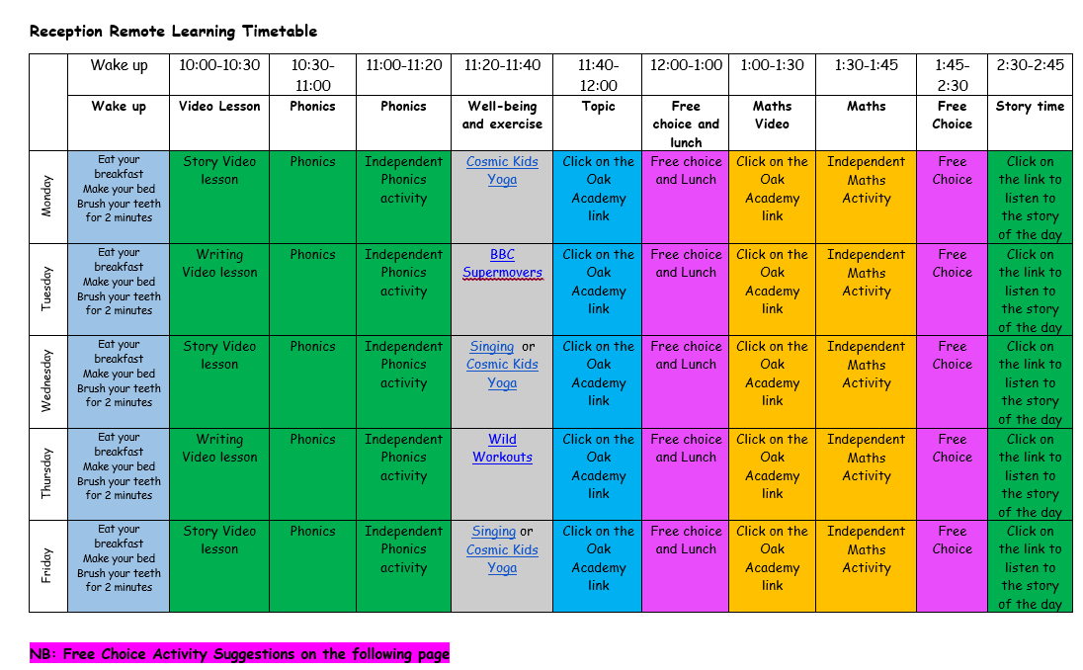
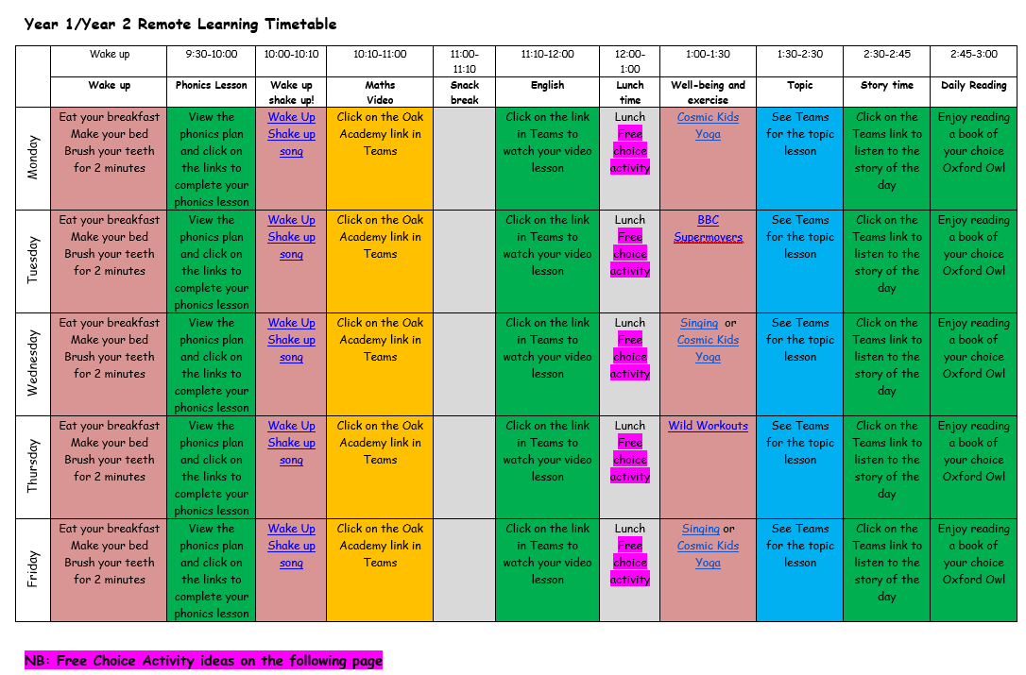

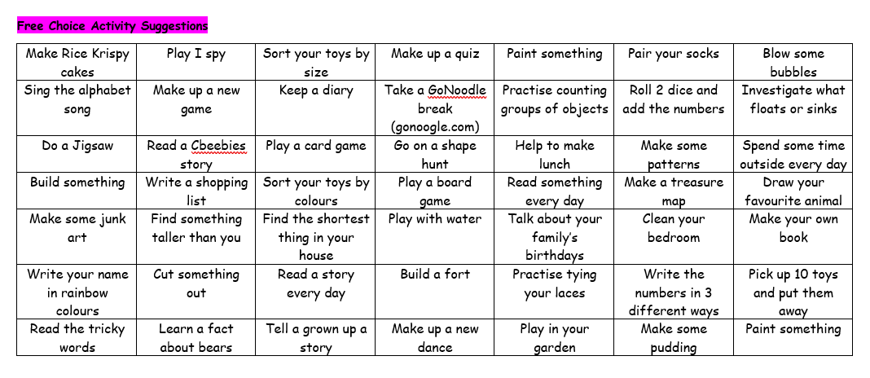

Appendix 2 – Videos and Live lessons – safeguarding yourself and the learners

When creating a video for online/remote learning.
These guidelines must be followed to safeguard yourself and the learners.
Failure to follow these guidelines could result in disciplinary action.

When videoing at home ensure that;
- The background is blank, with no family photographs or distinguishing features.
- If recording yourself, ensure professional clothes are worn.
- Ensure you watch videos back to check for any mistakes.
- When recording you should be the only person in the room.

Videos should be kept short and provide modelling to support the learner with their independent learning activities.

Videos should be, unless organised by SLT, of the class teacher of that class team.

Videos may be checked by SLT or other members of the leadership team at any time.

For more information about how you can safeguard yourselves and the children when remote learning;
https://www.gov.uk/guidance/safeguarding-and-remote-education-during-coronavirus-covid-19

Appendix 3 – Remote Learning Register

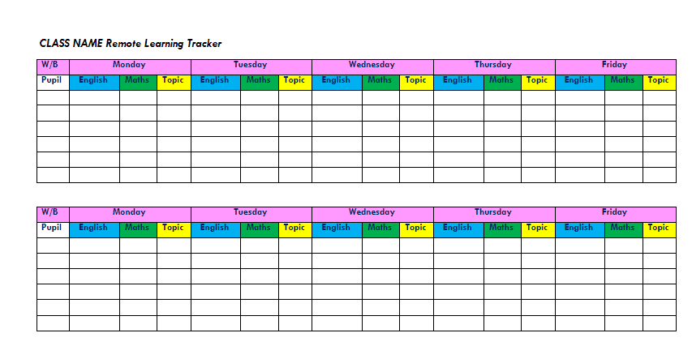
Use the trackers/registers to record when children have complete daily learning tasks (see below). These are available in the One Drive – Teaching Staff – Planning – Remote Learning. Please make a copy and then save with your class name and dates so that SLT can monitor communications. All safeguarding concerns must be reported separately and not on the class communication.

Appendix 4 – Where families have no devices for online learning

Families with no devices for online learning.
The school will ascertain the availability of devices of our families through a survey. From this staff will be made aware of those learners in their year group and be able to cater for them accordingly. Where possible, we will provide devices from which they can access the remote learning. Where this is not possible, packs will be created for pupils. The expectation would be that staff speak weekly to parents to monitor home learning and well-being.

Home learning
A paper copy of the home learning should be provided as appropriate where devices are not available. This includes the spellings, reading books, phonics cards and high frequency words, current maths learning from White Rose and English flipchart activities for that topic of learning. All learners have been given home learning books, which any work at home can be completed it. The expectation would be that staff speak weekly to parents to monitor home learning and well-being.

School Closure/Bubble Closure Learners
If a bubble closure occurs learning will be sent to children without devices by post. These learners would have learning provided in a pack which would be suitable for the full closure. The expectation would be that these are marked at home by the parents. Staff could review this learning on return, but no formal marking would take place. The expectation would be that staff speak weekly to parents to monitor home learning and well-being.

Equipment
School will issue / lend laptops or iPad to pupils where there is no availability at home. Parents should contact the school office if they do not have suitable devices at home.

Where poor internet connection is an issue, school will issue routers or dongles providing that they have discussed and had this agreed with the school. All queries may come to the school office.

Appendix 5 – Remote Learning Support Posters



