  Inspiring All to Excellence |  |  | 

Violet Way Academy

English as an Additional Language (EAL)

Introduction
In our academy, all our children are important, and this applies to all aspects of their education –their teaching and learning, their achievements, their attitudes, and their well-being. We encourage all our children to aim for the highest possible standards, and we take account of each child's individual needs and experiences.

At Violet Way Academy, a number of our children may have particular requirements with regard to learning and assessment, and these are linked to their progress in learning English as an additional language.

For children who are learning English as an additional language, their ability to participate in the full curriculum may well be in advance of their current ability to communicate in English.

Being a speaker of more than one language is no disadvantage to educational achievement; indeed, multilingualism is associated with success. This school recognises the importance of community languages in their own right, and the ability of their speakers to acquire other languages.

Aims
The aim of this policy is to help ensure that we meet the full range of needs of those children who are learning English as an additional language (EAL).

- We will celebrate the culture and linguistic diversity in our school through our teaching and learning.
- We will create and maintain a welcoming and supportive whole-school ethos of respect that is clear, explicit, articulated and shared so pupils make the best possible start to their life.
- We will have high expectations for all.
- We will ensure children progress from newly arrived limited English to fluency in the shortest possible time.
- We will set challenging targets for each learner and monitor progress against expectations continuously throughout the child’s schooling.

Role and responsibilities
All staff are responsible for developing EAL learners.

Headteacher
- The Headteacher is responsible for ensuring that staff receive suitable training and support for effective curriculum provision, high-quality teaching and learning and SEND in order to ensure staff are equipped to support the development of all pupils, including those with English as an additional language.
- The Headteacher will maintain and revise the EAL Policy.
- The Headteacher will ensure that assessment and monitoring is taking place.

Teachers will
- Identify and support pupils with EAL, including providing suitable resources (such as visuals , communication fans, IT resources, PENpal) also see Strategies section of this policy
- Liaise with SENDCO to ensure classroom provision is effective in meeting the needs of learners with EAL.
- Use EAL assessment resources as appropriate to identify English proficiency and use this to identify how they can be best supported.

The SENDCO will
- Liaise with class teachers to identify and support EAL pupils.
- Work with teachers to ensure effective and appropriate support is being given throughout the school to learners with English as an additional language.
- Manage resource materials and equipment to ensure sufficiency and adequacy.
- Identify EAL learners with SEND.
- Monitor standards of teaching and learning of learners with EAL.
- Consult with external agencies as required.
- Contribute to the school improvement plan in the areas of responsibility to identify development points and arrange for improved provision.

The Assessment Lead will:
- Ensure the progress of pupils with EAL is monitored and liaise with SENDCO and teachers to ensure that there learning needs are supported.
- Organise any access arrangements - The statutory assessment arrangements allow for access arrangements for children who are learning English as an additional language.
- Contribute to the school improvement plan in the areas of responsibility to identify development points and arrange for improved provision.

Induction
For newly arrived pupils, we will work with the child and their family to get to know them, celebrate their home language and culture and identify their needs. We have multi-lingual staff in school that can support induction and administration where appropriate.

Children will have a tour of the school to help them become familiar with the setting and, where possible, new arrivals will be paired up with class buddies that are the best possible role model in terms of language and behaviour.

An initial assessment of reading, writing, math and survival language will take place to baseline pupils with EAL as appropriate.

We have PENpals in school, which can be utilized to support the induction process. PENpal is a multi-lingual touch and read talking pen with a key phrases sheet and books to support learners with EAL (and their parents) with communication.

Strategies to support learners with EAL
- All classes will celebrate cultural diversity through the curriculum.
- Using the home or first language where appropriate.
- Visual support; posters, objects, non-verbal clues, pictures, demonstration and the use of gestures.
- Effective role models of speaking, reading and writing.
- Providing appropriate opportunities for talking, and using talking to support writing.
- Support to learn key vocabulary.
- Opportunities for role play.
- Pre-teach/discussions provided before and during reading and writing activities.
- Using texts and materials that suit their ages and learning stages.
- Providing support through IT, video and audio materials, dictionaries and translators, readers, and amanuenses.
- Additional 1-1 or small group interventions as appropriate.
- Staff are supported with outside help for specific children where appropriate.

In the Early Years Foundation Stage (EYFS), we will provide opportunities for children to develop their English, and we provide support to help them take part in activities.

The EYFS helps children learning English as an additional language by:
- building on their experience of acquiring language at home and in the wider community, so that this experience supports their developing use of English;
- providing a range of opportunities for them to engage in English speaking and listening activities, with peers and with adults;
- providing opportunities for children to hear their home languages, as well as English;
- providing written materials in the children's home languages, as well as in English.

Assessment
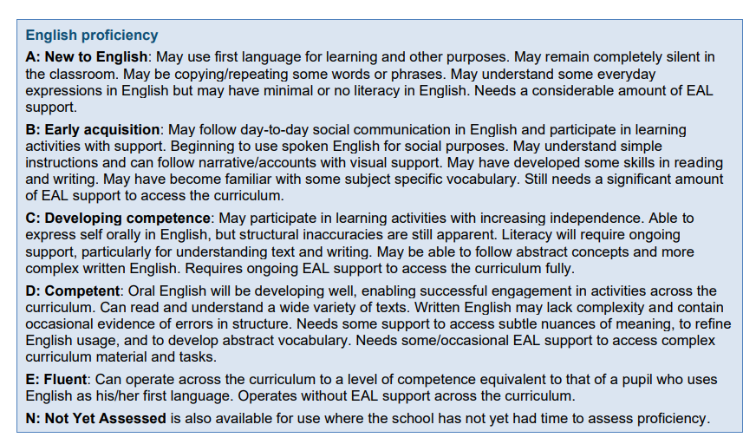
As appropriate, children’s proficiency in English is assessed as soon as possible based on the following DfE English proficiency scale:
Teachers can use this assessment scale to identify how they can support their EAL learners and monitor their progress. Data analysis is carried out by the Assessment Lead and this is discussed with the SENDCO to monitor the progress of EAL pupils. The statutory assessment arrangements allow for access arrangements for children who are learning English as an additional language.

Parent partnership
Our school recognises the key importance of the partnership with, parents and carers.

We aim to:
- Provide a comfortable and welcoming environment where parents/carers can discuss any concerns.
- Take into account parents’/carers knowledge, views and attitudes.
- Consult with and involve parents/carers at all stages of their child’s learning journey.
- Provide parents/carers with information on school policies, support and services provided by the school and Staffordshire.
- Support parents/carers with home activities designed to reinforce work in school.
- Enlist the help of parents/carers to support in school.
- Hold curriculum workshops for parents/carers and to support them and enable them to share their culture.

Equal opportunities
At Violet Way Academy, we are committed to equal opportunities for all, irrespective of race, gender, sexuality, disability or religion.

Monitoring and review
This policy is monitored by the governing body and will be reviewed at least every two years.

