  Inspiring All to Excellence |  |  | 

Violet Way Academy

Asthma

Background
Violet Way Academy recognises that asthma is a widespread, serious but controllable condition affecting many pupils at the school. This school encourages pupils with asthma to achieve their potential in all aspects of school life by having a clear guidance that is understood by school staff and pupils. All staff who come into contact with pupils with asthma will be provided with training on asthma and/or First Aid courses which are renewed in line with recommended guidance.

Asthma medicines
- Asthma inhalers come in a variety of colours, usually only blue inhalers will be seen school.
- Immediate access to reliever medicines (blue inhaler e.g., Salbutamol) is essential.
- Pupils with asthma are encouraged to carry their reliever inhaler as soon as the parent/carer, doctor or asthma nurse agrees they are mature enough.
- Parents/Carers are required to complete an asthma card with information about triggers and medication procedures for their child.
- Parents/carers are asked to ensure that the school is provided with a labelled spare reliever (blue) inhaler. All inhalers must be labelled with the child’s name by the parent/carer.
- School staff are not required to administer asthma medicines to pupils except in an emergency.

Procedures in school for asthma medicines
- Parents/Carers are required to complete a School Asthma card (see appendix A) with information about triggers and medication procedures for their child.
- All inhalers are kept in the classrooms in a box. The box is taken with the class, for example, when going to PE.
- All school staff will let pupils take their own medicines when they need to, supervising their administration.
- The school keeps emergency inhalers in school which can be used if the pupil’s prescribed inhaler is not available (for example, because it is broken, or empty, or the child requires it in an emergency during break time, and during emergency evacuation). However, parents must sign to consent to their child’s use of an emergency inhaler on their child’s School Asthma card
- The emergency inhaler is kept in the school office.
- School staff are not required to administer asthma medicines to pupils (except in an emergency), however many of the staff at this school are happy to support children wherever necessary.

Record keeping
When joining the school (in Reception or at any other time), parents / carers will be asked if their child has any medical conditions including asthma on their enrolment form. This is checked regularly.

Parents/carers are asked to make the school aware of any changes to medication or dosages. Asthma is recorded as a medical condition on the school’s information management programme.

Exercise and activity – PE and games
Taking part in sports, games and activities is an essential part of school life for all pupils. All teachers will know which children in their class have asthma and all external PE teachers at the school will be made aware of which pupils have asthma.

Pupils with asthma will be encouraged to participate fully in all PE lessons. Teachers and Teaching Assistants will remind pupils whose asthma is triggered by exercise, to take their inhaler before the lesson, and to thoroughly warm up and down before and after the lesson. Each pupil’s inhaler will be labelled and kept accessibly within the lesson. If a pupil needs to use their inhaler during a lesson they will be encouraged to do so.

Classroom teachers will follow the same principles as described above for games and activities involving physical activity.

Out-of-hours sport
There has been a large emphasis in recent years on increasing the number of children and young people involved in exercise and sport in and outside of school. The health benefits of exercise are well-documented, and this is also true for children and young people with asthma. It is therefore important that the school involves pupils with asthma as much as possible in after school clubs.

External PE teachers, classroom teachers and out-of-hours school sport coaches will be aware of the potential triggers for pupils with asthma when exercising, tips to minimise these triggers and what to do in the event of an asthma attack. They will be made aware of any child in their club who uses an asthma inhaler.

Please refer to Appendix C for further information about asthma and exercise (Guidelines for teachers, PE teachers and sports coaches).

School environment
The school will do all that it can to ensure the school environment is favourable to pupils with asthma. The school will have a smoke free rule. As far as possible the school will not use chemicals in science and art lessons that are potential triggers for pupils with asthma.

When a pupil is falling behind in lessons
If a pupil is missing a lot of time at school or is always tired because their asthma is disturbing their sleep at night, the class teacher will initially talk to the parents/carers to agree how to prevent their child from falling behind.

If appropriate, the teacher will then talk to the Headteacher and SENDCO about the pupil’s needs. Advice will be sought from the school nurse team. The school recognises that it is possible for pupils with asthma to have Special Educational needs due to their asthma.

Asthma attacks
All staff at Violet Way Academy should ensure that they are familiar with the guidance in this guidance and that they know what to do in the event of an asthma attack. In the event of an asthma attack the school follows the procedure outlined below (and Appendix B). Good practice suggests that copies are printed and displayed in the school office, staff room and relevant locations including classrooms where a pupil is known to have severe asthma.

ASTHMA ATTACK PROCEDURE
What to do in the event of an asthma attack:
If a child has an asthma attack—parents will always be called immediately. The following procedure will be used:
1. Make sure the child takes their usual dose of reliever inhaler (usually blue).
2. Sit the child upright, get them to take slow steady breaths. Staff member to keep calm and reassure them, DO NOT LEAVE THEM ALONE.
3. Continue to give two puffs of reliever inhaler (one puff at a time) every two minutes, up to 10 puffs.
4. If the child does not feel better after taking their reliever inhaler as above or if you are worried at any time call 999.
5. If the ambulance does not arrive within 10 minutes repeat step 3 while you wait.
Remember to:
• Stay calm and reassure the child. Stay with the child until they feel better. The child can return to school activities when they feel better
• If an ambulance is required the child’s parents or carers should be contacted AFTER the ambulance has been called.
• A member of staff should always accompany a child taken to hospital by ambulance and stay with them until a parent or carer arrives. All staff who come into contact with pupils with asthma know what to do in the event of an asthma attack.

Signs of an asthma attack include:
- Persistent cough (when at rest)
- A wheezing sound coming from the chest (when at rest)
- Being unusually quiet
- The child complains of shortness of breath at rest, feeling tight in the chest (younger children may express this feeling as a tummy ache)
- Difficulty in breathing (fast and deep respiration)
- Nasal flaring
- Being unable to complete sentences
- Appearing exhausted
- A blue / white tinge around the lips
- Going blue

After a Minor Asthma Attack
- Minor attacks should not interrupt the involvement of a pupil with asthma in school.
- When the pupil feels better, they can return to school activities.
- The parents/carers must always be told if their child has had an asthma attack.

Appendix A
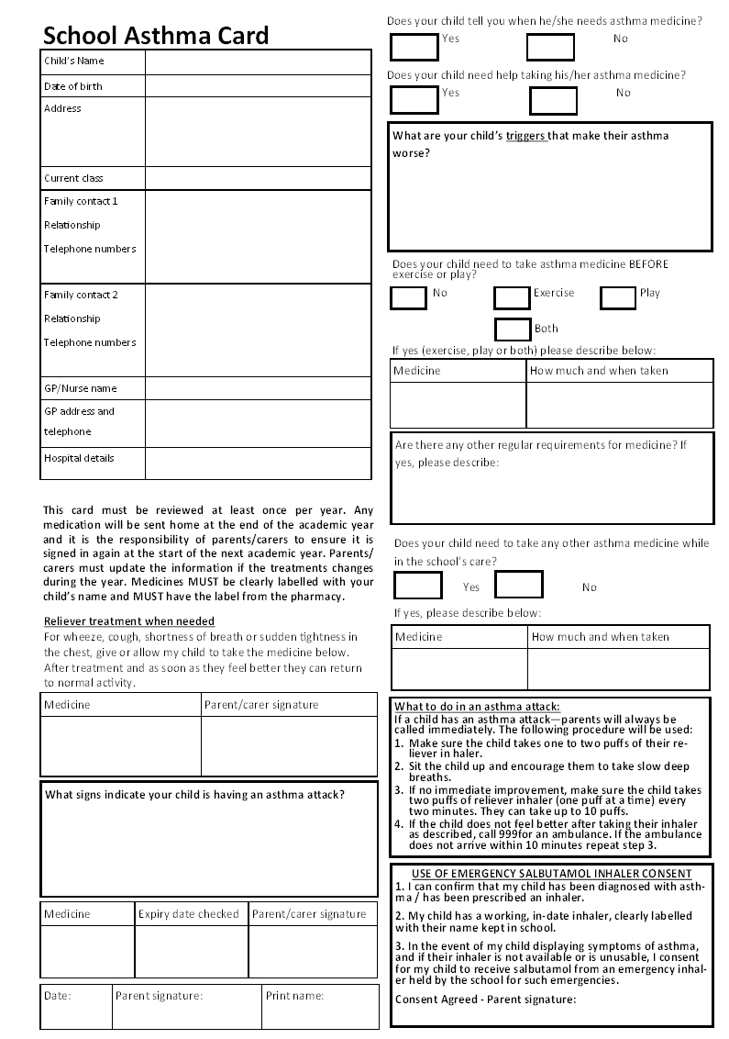

Appendix B

ASTHMA ATTACK PROCEDURE

What to do in an asthma attack:
If a child has an asthma attack—parents will always be called immediately.

Remember: Asthma symptoms include, coughing, wheezing, shortness of breath, tightness in chest or being unusually quiet. A child might be having an asthma attack if:
• Their reliever inhaler (usually blue) doesn't help
• Their symptoms are getting worse (cough, breathlessness, wheeze or tight chest)
• They're too breathless to speak
• There’s a blue tinge on their skin or lips (this is a sign of lack of oxygen in the blood).

If a child has an asthma attack, the following procedure will be used:

1. Make sure the child takes their usual dose of reliever inhaler (usually blue) .
2. Sit the child upright, get them to take slow steady breaths. Staff member to keep calm and reassure them, DO NOT LEAVE THEM ALONE.
3. Continue to give two puffs of reliever inhaler (one puff at a time) every two minutes, up to 10 puffs.
4. If the child does not feel better after taking their reliever inhaler as above or if you are worried at any time call 999.
5. If the ambulance does not arrive within 10 minutes repeat step 3 while you wait.

Remember to:
• Stay calm and reassure the child. Stay with the child until they feel better. The child can return to school activities when they feel better
• If an ambulance is required the child’s parents or carers should be contacted AFTER the ambulance has been called.
• A member of staff should always accompany a child taken to hospital by ambulance and stay with them until a parent or carer arrives.

Appendix C

ASTHMA AND EXERCISE GUIDELINES FOR TEACHERS, PE TEACHERS AND SPORTS COACHES

As a teacher, PE teacher or sports coach there’s a lot you can do to support children with asthma in your school or club. Use our checklist to make sure children with asthma stay safe and can take part in exercise and activities along with everyone else in the group.

Ask the right questions:
If you know you have a child with asthma in your exercise session check in with them at the start of the session by asking:
- How is your asthma today?
- What are the things that set off your asthma (your triggers)?
- Do you have any concerns about today’s activity?

Inhalers are kept in the classroom in a box and teachers or sports coaches must ensure the box is taken with the class or group for PE or after school club lessons so there is easy access.

Make sure you:
• Don’t make a big issue of their asthma in front of the other children.
• Don’t make them feel uncomfortable about having asthma.
Make sure everyone:
• Warms up and cools down – starting an exercise activity slowly and building up is better for children with asthma.
• Avoid use of aerosol deodorants/body sprays because these can be an asthma trigger.

If a child starts having asthma symptoms (coughing, wheezing, shortness of breath, tightness in chest or being unusually quiet):
• Let them stop the activity for a while and take their reliever inhaler. Make sure they wait five minutes after their symptoms have gone before joining in again if they can.
• If they do have to sit out the rest of the session, invite them to stay involved - maybe they can be in charge of the scoring.
• Keep in touch with the child’s teacher, the school nurse if there is one, and the child’s parents and let everyone know if there were any problems during the session.
• Keep a record of the time, date and how many puffs of their inhaler the child took.
• Refer to the asthma attack information for what to do if symptoms develop into an asthma attack.
• Keep a log of what went well and what didn’t go so well – some sports are better than others for children with asthma – support them in finding something they’re able to do.

A child might be having an asthma attack if:
• Their reliever inhaler (usually blue) doesn't help
• Their symptoms are getting worse (cough, breathlessness, wheeze or tight chest)
• They're too breathless to speak
• There’s a blue tinge on their skin or lips. This is a sign of lack of oxygen in the blood.

What you need to do if a child in your class or group has an asthma attack:
Step 1. Make sure the child takes one to two puffs of their reliever inhaler
Step 2. Sit the child up and encourage them to take slow deep breaths.
Step 3. If no immediate improvement, make sure the child takes two puffs of reliever inhaler (one puff at a time) every two minutes. They can take up to 10 puffs.
Step 4. If the child does not feel better after taking their inhaler as described, call 999 for an ambulance.
Step 5. If the ambulance does not arrive within 10 minutes repeat step 3.

After an attack:
• Let parents and class teachers know.
• Keep a written record of the attack, the situation in which it happened, and, if known, a note of what triggered it so you can safeguard against it happening again
• Encourage parents to take their child to see their GP or asthma nurse for an urgent same-day appointment. Even if the child didn’t have an asthma attack, but you saw them having symptoms when they were exercising, let the parents know.

Common exercise triggers: Symptoms:
• Cold air or sudden change in temperature • Coughing
• Pollution • Wheezing
• Long distance running • Tightness in the chest
• Chlorine • Shortness of breath
• Dusty equipment • Difficulty breathing
• Pollen, including grass cutting • Unusually quiet
• Stress or excitement
• Ice cold drinks

Call the Asthma UK Helpline on 0800 121 62 44 or visit the website www.asthma.org.uk for more advice or to order asthma resources.

