Violet Way Academy
Year R Curriculum Autumn Term

English  Children will begin by reading lots of traditional stories such as Goldilocks, The 3 Little Pigs, Little Red Hen, Gingerbread man, Little Red Riding Hood and The Ugly Duckling. They will also look at non-fiction books about Ourselves, Harvest and Food to find out information about our topic.  Children will be learning how to listen to stories attentively and respond to questions/give comments about what they have heard. | Maths  Children will have a maths lesson 3 times a week in their class. Over a term children will be taught aspects of: Number and Shape, space and measure from the EYFS Development matters. Reception children will begin by practicing counting up to 10, writing the numbers in the correct way, counting objects and using the language of more/fewer. Children will also have the opportunity to experience maths outdoors and in our woodlands.
Phonics  Children will have a daily phonics lesson in class. We do not follow a set scheme but we use the phonic sound cards from Read Write Inc to help teach the children the sound along with a rhyme to help them to remember the letter formation e.g. m – Maisie mountain mountain. We also use the Jolly Phonic songs. This term the focus will be on holding a pencil correctly, learning all the initial sounds and how to write them correctly and practicing to write their name. | Homework  Reception children will have weekly homework. The sounds that have been covered in school that week will be attached to their homework book and letter formation practice will be sent home. Maths and topic homework is sent every half-term.  Homework books will be sent home on a Friday, please can they be returned to school on the following Thursday.
Reading for Pleasure  It is important that children develop a love for reading and have a chance to choose their own books and to read for pleasure. To instil this love of reading we have weekly library sessions were children can choose a book of their choice. This may be a fiction book, non-fiction book, a book they could read themselves easily or a book that they need an adult to read to them. Children must return the book from the previous week before bringing a new one home. We also have story time as a whole class at the end of the day. In this time we will be reading books linked to the topic ‘Traditional Tales’ or from our class book corner. | Additional Information

Ourselves/
Traditional stories

Expressive Arts
and Design
I will be learning:
- To choose the appropriate colours to paint a picture of myself
- To hold a paint brush correctly
- To clap in time to a beat
- To sing songs during our assemblies and during hymn practice

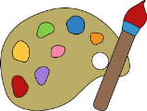
Autumn Term Curriculum Newsletter Autumn Term Curriculum Information for Parents

Communication and Language
I will be learning:
- To listen to traditional tales
- To respond to instructions
- To follow a story without pictures or prompts

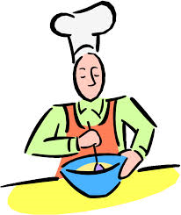
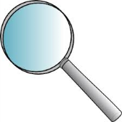
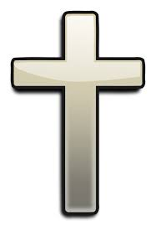
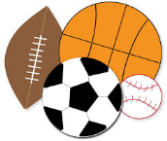
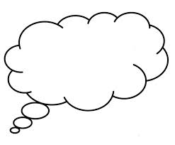
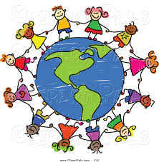
Cooking
I will be learning:
- The steps involved to make porridge
- The steps involved to make bread

Understanding the
World
I will be learning:
- To look at changes in the weather
- To observe where vegetables grow during harvest time

Physical Development
I will be learning:
- To play some playground games
- To play safely on the playground
- To find my own place in the hall
- To run, hop, skip, jump

Personal, Social and Emotional Development
I will be thinking about:
- How to play nicely with my friends
- How to be brave and try new things
- How I can use manners to be polite
- How to follow the school rules
- How to overcome fears

