Violet Way Academy
Year R Curriculum Summer Term

English  Children will listen to a range of texts themed around ‘minibeasts’ such as The Hungry Caterpillar, Argh!Spider, The Bad Tempered Ladybird and The Very Quiet Cricket.  Children will be learning how to listen to stories attentively and respond to questions/give comments about what they have heard. | Maths  Children will have a maths lesson 3 times a week in their class. Over a term children will be taught aspects of: Number and Shape, space and measure from the EYFS Development matters. Reception children will begin by practicing counting up to 10, writing the numbers in the correct way, counting objects and using the language of more/fewer. Children will also have the opportunity to experience maths outdoors and in our woodlands.
Phonics  Children will have a daily phonics lesson in class. We do not follow a set scheme but we use the phonic sound cards from Read Write Inc to help teach the children the sound along with a rhyme to help them to remember the letter formation e.g. m – maisie mountain mountain. We also use the Jolly Phonic songs. This term the focus will be revising ‘special friends’ – two or more letters that when joined together make one sound e.g. ay,ee,igh,ow,oo. Children will also focus on words beginning or ending with consonant blends such as bl,br, fr, fl. | Homework  Reception children will have weekly homework. The sounds that have been covered in school that week will be attached to their homework book and letter formation practice will be sent home. Maths and topic homework is sent every half-term.  Homework books will be sent home on a Friday, please can they be returned to school on the following Thursday.
Reading for Pleasure/Library  It is important that children develop a love for reading and have a chance to choose their own books and to read for pleasure. To instil this love of reading we have weekly library sessions were children can choose a book of their choice. This may be a fiction book, non-fiction book, a book they could read themselves easily or a book that they need an adult to read to them. Children must return the book from the previous week before bringing a new one home. We also have story time as a whole class at the end of the day. In this time we will be reading books linked to the topic of ‘Minibeasts’ or from our class book corner. | Additional Information  The children will partake in a ‘Minibeast’ experience in school where they will get the chance to look at creepy crawlies up close and ask questions to a ‘Bug expert!’. The children also get to look at the butterfly life cycle up close by watching caterpillars turn into butterflies in their very own classroom!

Expressive Arts
and Design
I will be learning:
- To compose music to match minibeasts movements
- To use split pins to create a caterpillar
- To design my own bug using colour, texture and form
- To make glitter spider webs
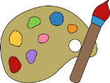
Autumn Term Curriculum Newsletter Summer Term Curriculum Information for Parents
Minibeasts

Communication and Language
I will be learning:
- To listen carefully to factual information about minibeasts
- To pose questions – What? Why? When? How?
- To retell stories linked to our topic

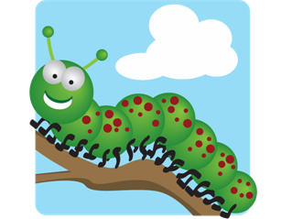
Understanding the
World
I will be learning:
- The similarities and differences in living things such as minibeasts
- About the habitats, food and life cycle of minibeasts
- Use laptops/microscopes to investigate
- To observe the caterpillar life cycle first hand

Physical Development
I will be learning:
- How to handle minibeasts
carefully and safely
- To move with good co-ordination and control at the ‘Bug ball’
Personal, Social and Emotional Development
I will be thinking about:
- Following rules on how to look after and care for minibeasts
- Working with others to find minibeasts in the woodlands

