Violet Way Academy
Year R Curriculum Autumn Term

English  Children will begin by reading texts linked to the topic such as Can’t you sleep little bear?, Owl Babies and non-fiction texts about nocturnal animals.  Children will be learning how to listen to stories attentively and respond to questions/give comments about what they have heard. | Maths  Children will have a maths lesson 3 times a week in their class. Over a term children will be taught aspects of: Number and Shape, space and measure from the EYFS Development matters. Reception children will begin by practicing counting up to 10, writing the numbers in the correct way, counting objects and using the language of more/fewer. Children will also have the opportunity to experience maths outdoors and in our woodlands.
Phonics  Children will have a daily phonics lesson in class. We do not follow a set scheme but we use the phonic sound cards from Read Write Inc to help teach the children the sound along with a rhyme to help them to remember the letter formation e.g. m – maisie mountain mountain. We also use the Jolly Phonic songs. This term the focus will be on holding a pencil correctly, learning all the initial sounds and how to write them correctly and practicing to write their name. | Homework  Reception children will have weekly homework. The sounds that have been covered in school that week will be attached to their homework book and letter formation practice will be sent home. Maths and topic homework is sent every half-term.  Homework books will be sent home on a Friday, please can they be returned to school on the following Thursday.
Reading for Pleasure/Library  It is important that children develop a love for reading and have a chance to choose their own books and to read for pleasure. To instil this love of reading we have weekly library sessions were children can choose a book of their choice. This may be a fiction book, non-fiction book, a book they could read themselves easily or a book that they need an adult to read to them. Children must return the book from the previous week before bringing a new one home. We also have story time as a whole class at the end of the day. In this time we will be reading books linked to the topic ‘Traditional Tales’ or from our class book corner. | Additional Information  During our topic on light and dark, Reception children will partake in a workshop from ‘Magical Mayhem’ during which they will explore UV and LED lights. They can also explore with UV paint. Please let your child’s teacher know if your child has any allergies.

Expressive Arts
and Design
I will be learning:
- To create a firework picture with different media
- To model clay to a desired effect
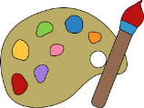
Autumn Term Curriculum Newsletter Autumn Term Curriculum Information for Parents
Light and Dark

Communication and Language
I will be learning:
- To share my ideas with the rest of the class
- To listen carefully to stories
- To talk confidently about information I have listened to

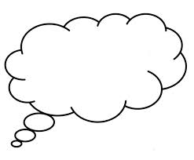
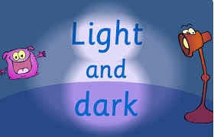
Physical Development
I will be learning:
- To find my own place in the hall
- To remember a dance routine
- To experiment with ways I can move my body
Understanding the
World
I will be learning:
- About which animals like to come out at night and use the word ‘nocturnal’
- What are sources of light
- Why there is dark and light
Personal, Social and Emotional Development
I will be thinking about:
- How to play nicely with my friends
- How to be brave and try new things
- How I can use manners to be polite
- How to follow the school rules
- How to overcome fears

