Violet Way Academy
Year R Curriculum Spring Term

English  Children will begin by listening to the traditional stories of ‘The Enormous Turnip’ and ‘Jack and the Beanstalk’. Across the topic, the children will write instructions of how to plant a seed, label plant drawings, create imaginary stories and write about the results of a growing experiment.  Children will be learning how to listen to stories attentively and respond to questions/give comments about what they have heard. | Maths  Children will begin to be taught Maths in set groups. This means the children may visit a different teacher for maths sessions. There will be 3 sessions a week and will follow the EYFS Development Matters document and the national curriculum. Children will also have the opportunity to experience maths outdoors and in our woodlands.
Phonics  Children will have a daily phonics lesson in class. We do not follow a set scheme but we use the phonic sound cards from Read Write Inc to help teach the children the sound along with a rhyme to help them to remember the letter formation e.g. m – maisie mountain mountain. We also use the Jolly Phonic songs. This term the focus will be learning ‘special friends’ – two or more letters that when joined together make one sound e.g. ay,ee,igh,ow,oo | Homework  Reception children will have weekly homework. The sounds that have been covered in school that week will be attached to their homework book and letter formation practice will be sent home. Maths and topic homework is sent every half-term.  Homework books will be sent home on a Friday, please can they be returned to school on the following Thursday.
Reading for Pleasure/Library  It is important that children develop a love for reading and have a chance to choose their own books and to read for pleasure. To instil this love of reading we have weekly library sessions were children can choose a book of their choice. This may be a fiction book, non-fiction book, a book they could read themselves easily or a book that they need an adult to read to them. Children must return the book from the previous week before bringing a new one home. We also have story time as a whole class at the end of the day. In this time we will be reading books linked to the topic of ‘Growing’ or from our class book corner. | Additional Information  During our topic on ‘Growth’, we also talk about human growth. We ask if the children could bring in a baby photograph of themselves at the beginning of this topic.  During the last week, we invite any parents with babies or toddlers to a ‘Growing talk’ where the children can ask questions and discuss growth from a baby to a toddler and so forth. We also invite any grandparents who would like to share with us what it was like when they were children to a ‘Grandparent talk’.

Expressive Arts
and Design
I will be learning:
- To sing songs about growing
- To compose music to plant growth
- To make observational drawings of plants
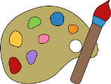
Autumn Term Curriculum Newsletter Spring Term Curriculum Information for Parents
Growing

Communication and Language
I will be learning:
- To listen and respond to questions about the story
- To respond to ‘how’ and ‘why’ questions when completing experiments
- To talk about sequences of growth in plants and humans

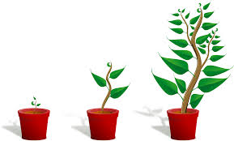
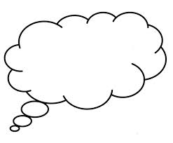
Personal, Social and Emotional Development
I will be thinking about:
- How to respect nature and flowers
- To think about traditions in other cultures including human growth
Understanding the
World
I will be learning:
- To compare different plants and talk about similarities and differences
- To understand what plants/animals need in order to survive and grow
- To understand life cycles
- To label the parts of a plant
Physical Development
I will be learning:
- How vegetables grow and help us to be healthy
- To handle equipment such as a
Trowel, hoe, seed sorting with tweezers

