Violet Way Academy
Year R Curriculum Spring Term

English  Children will begin by listening to the story of ‘The Great Race’. We will listen to the story, re-enact and sequence it. We will discuss Chinese foods and write a Chinese menu. The children will also think about describing words for each animals involved in the race.  Children will be learning how to listen to stories attentively and respond to questions/give comments about what they have heard. | Maths  Children will have a maths lesson 3 times a week in their class. Over a term children will be taught aspects of: Number and Shape, space and measure from the EYFS Development matters. Reception children will begin by practicing counting up to 10, writing the numbers in the correct way, counting objects and using the language of more/fewer. Children will also have the opportunity to experience maths outdoors and in our woodlands.
Phonics  Children will have a daily phonics lesson in class. We do not follow a set scheme but we use the phonic sound cards from Read Write Inc to help teach the children the sound along with a rhyme to help them to remember the letter formation e.g. m – maisie mountain mountain. We also use the Jolly Phonic songs. This term the focus will be learning ‘special friends’ – two or more letters that when joined together make one sound e.g. ay,ee,igh,ow,oo | Homework  Reception children will have weekly homework. The sounds that have been covered in school that week will be attached to their homework book and letter formation practice will be sent home. Maths and topic homework is sent every half-term.  Homework books will be sent home on a Friday, please can they be returned to school on the following Thursday.
Reading for Pleasure/Library  It is important that children develop a love for reading and have a chance to choose their own books and to read for pleasure. To instil this love of reading we have weekly library sessions were children can choose a book of their choice. This may be a fiction book, non-fiction book, a book they could read themselves easily or a book that they need an adult to read to them. Children must return the book from the previous week before bringing a new one home. We also have story time as a whole class at the end of the day. In this time we will be reading books linked to the topic of ‘Chinese New Year’ or from our class book corner. | Additional Information

Expressive Arts
and Design
I will be learning:
- To make Chinese music exploring different sounds of instruments
- To listen carefully to Chinese music
- To make Chinese lanterns and fans
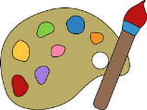
Autumn Term Curriculum Newsletter Spring Term Curriculum Information for Parents
Communication and Language
I will be learning:
- To ask and answer questions about food I have tasted
- To engage in role play in the Chinese restaurant
Chinese New Year

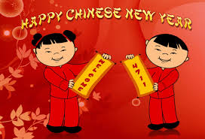
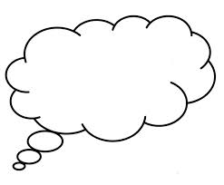
Personal, Social and Emotional Development
I will be thinking about:
- Trying new things and expressing likes/dislikes
- To take turns and share resources in the role play corner
- To respect differences in other cultures
Understanding the
World
I will be learning:
- To discuss and taste different foods from different cultures
- To find out about Chinese customs and the differences with British culture
Physical Development
I will be learning:
- To move to Chinese music in PE and move rhythmically
- To use the tabards to re-enact ‘The Great Race’

